|  |  |  |  |
| --- | --- | --- | --- |
| Description: Description: S:\AdminShared\All Staff\1 College Logo's\Baldivis_Logo_colour.jpgName: | \_\_\_\_\_\_\_\_\_\_\_\_\_\_\_\_\_\_\_\_\_\_\_\_\_\_\_\_\_\_\_\_\_\_\_\_\_\_\_\_\_\_\_\_\_\_\_ | | Date: *\_\_\_\_\_\_\_* |
|  | **Year 11 Applications**  **Test 5, 2020**  **Topics – Univariate Statistics** | | 37  = % |
| **Total Time:** | *40 minutes* |  | |
| **Total Reading:** | *3**minutes* |
| **Total Working:** | *37 minutes* |
| **Equipment:** | *SCSA Formula Sheet; 1 page notes (A4 one side,* ***Unfolded****), CASIO ClassPad; Scientific Calculator* | | |

**Resource Free Section – 9 min 1 min reading time [9 marks]**

**1. [4 marks]**

The following is a box-plot representing scores $1, 1, a, 3, b, 5, c, d$



Determine the values of $a, b, c$ and $d$.

**2. [5 marks]**

The following information was collected from patrons working out at the local gymnasium. Classify the data as nominal (N), ordinal (O), discrete (D) or continuous (C). Circle the correct response.

1. Gender. N O D C
2. Brand of shoes worn. N O D C
3. Height. N O D C
4. Number of visits to the gym in the last 7 days. N O D C
5. Rating the facilities as good, average or poor. N O D C

**Resource Section – 28 min plus 2 min reading time [28 marks]**

NAME: \_\_\_\_\_\_\_\_\_\_\_\_\_\_\_\_\_\_\_\_\_\_\_\_\_\_\_\_\_\_\_\_\_\_\_\_\_\_\_\_

**3. [1, 2, 4 = 7 marks]**

Tanya measures the height (in cm) of a group of Year 10 students and produces the following set of data.

149, 151, 152, 154, 158, 161, 161, 163, 165,

165, 165, 171, 171, 173, 177, 178, 181

1. Complete the following grouped frequency table for the heights of these Year 10 students.

|  |  |  |
| --- | --- | --- |
| **Height (cm)** | **Tally** | **Frequency** |
| 140 − < 150 |  |  |
| 150 − < 160 | |||| | 4 |
| 160 − < 170 |  |  |
| 170 − < 180 |  |  |
| 180 − < 190 |  |  |

1. Present the frequency table as a histogram on the following axes.

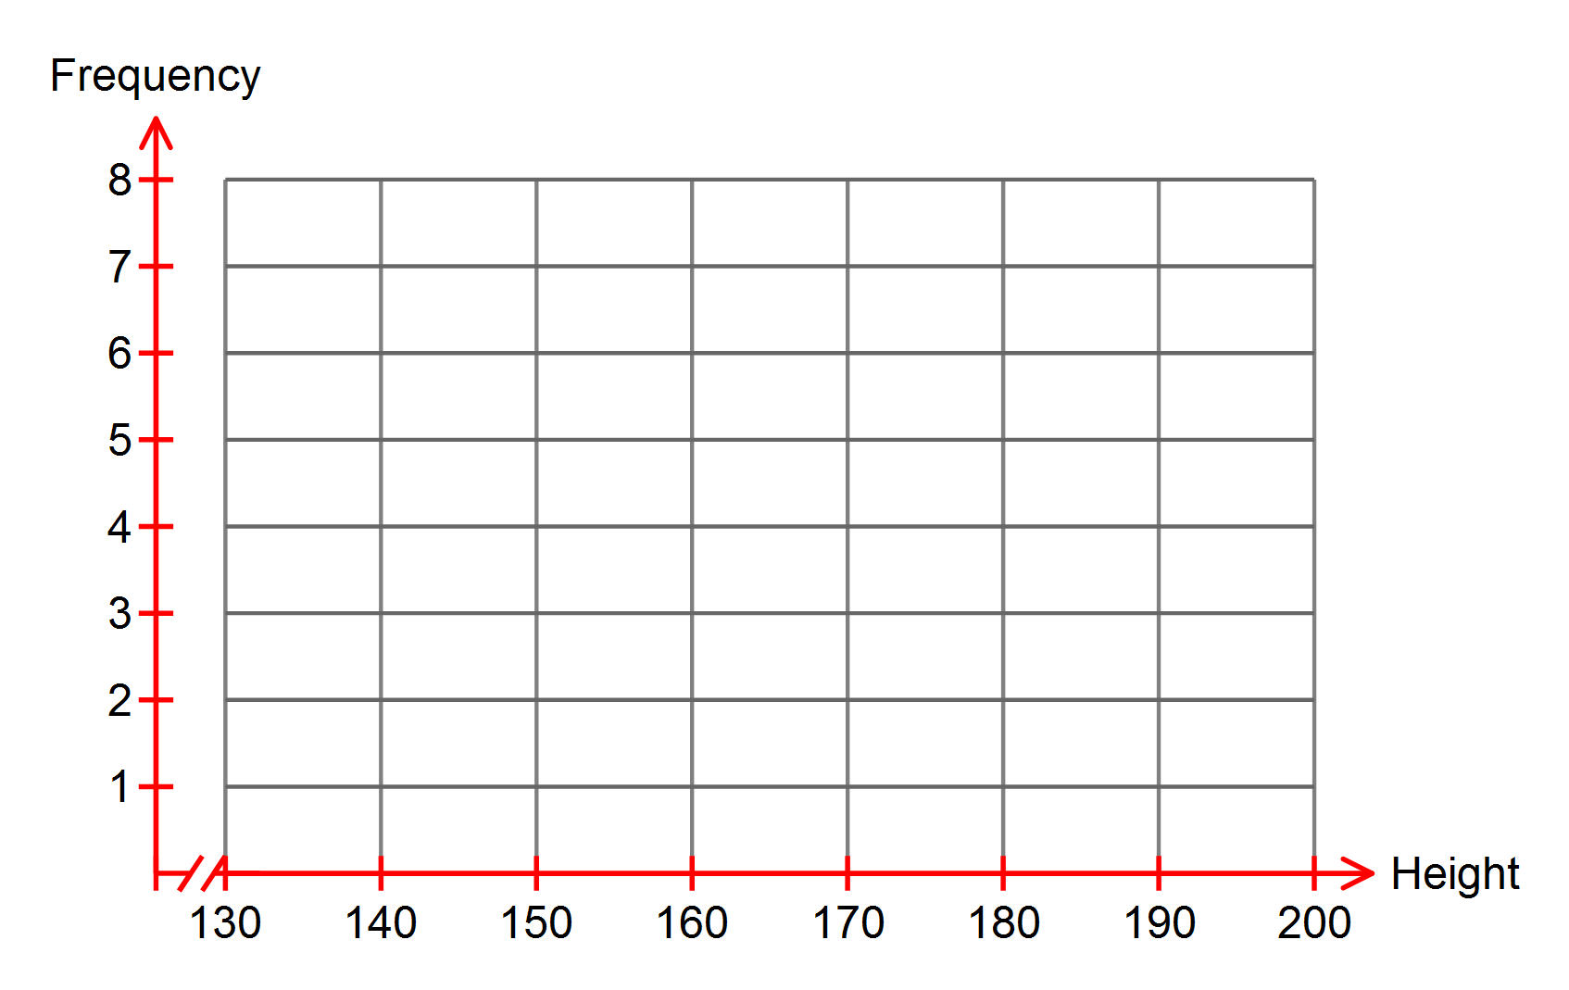

1. Describe the distribution of the heights of the Year 10 students.

**5. [2, 2, 1 = 5 marks]**

Fifty high school students were asked how much time (to the nearest hour) they had spent on studying on the previous weekend. The results are summarised in the table below.

|  |  |  |  |  |  |  |  |
| --- | --- | --- | --- | --- | --- | --- | --- |
| No. of Hours | 1 | 2 | 3 | 4 | 5 | 6 | 7 |
| No. of Students | 3 | 5 | 10 | 18 | 8 | 4 | 2 |

1. Calculate the mean time spent in study on the weekend.
2. Calculate the standard deviation of the time spent in study.

Suppose another group of 20 students spent an average of 2.35 hours studying on the same weekend.

1. Calculate the mean time spent in study for the combined group of students.

**4. [4 marks]**

A farmer is trying to determine whether a new fertiliser is increasing the growth of his crops.

He has two separate fields where he is growing crops. He uses the new fertiliser on only one of the fields and not the other. He records the heights of the crops and analyses the statistics.

The heights of the 10 crops in metres are shown in the tables below.

Field A

|  |  |  |  |  |  |  |  |  |  |
| --- | --- | --- | --- | --- | --- | --- | --- | --- | --- |
| 1 | 2 | 3 | 4 | 5 | 6 | 7 | 8 | 9 | 10 |
| 5 | 8 | 12 | 14 | 16 | 6 | 5 | 8 | 18 | 6 |

Field B

|  |  |  |  |  |  |  |  |  |  |
| --- | --- | --- | --- | --- | --- | --- | --- | --- | --- |
| 1 | 2 | 3 | 4 | 5 | 6 | 7 | 8 | 9 | 10 |
| 5 | 6 | 5 | 7 | 8 | 7 | 8 | 5 | 4 | 6 |

The farmer concludes that the fertiliser does work but that it is not consistent.

Use statistical measures for reasoning to back-up the farmer’s conclusion, and state which field would be the one which received the new fertiliser.

**6. [1, 2, 2, 5, 2 = 12 marks]**

Data is collected and analysed following a medical study. The study involved two separate groups. The people in the one group received a trial medicine to relieve cold and flu symptoms and the other group received a placebo.

The box plot below is for the group who received the medicine and shows the number of days each person showed cold and flu symptoms for.

**a)** State the median number of days the people in the group showed symptoms.

**b)** Calculate the inter-quartile range and the range of the number days people in this group showed symptoms.

Another person who took part in the study, who was not included in the box and whisker plot above, showed symptoms for 6 days.

**c)** What effect will this new data have on the range and median?

For the other group who only received the placebo medicine, the number of days they each showed cold and flu symptoms are represented in the table below.

|  |  |
| --- | --- |
| Number of Days with Cold and Flu Symptoms | Frequency |
| 1 | 0 |
| 2 | 1 |
| 3 | 2 |
| 4 | 5 |
| 5 | 6 |
| 6 | 6 |
| 7 | 1 |

**d)** For this second group, calculate correct to 2 decimal places:

i) the mean

ii) the standard deviation

iii) the median

iv) the inter-quartile range

v) the range

**e)** Upon checking the records it is found that one person showed symptoms for 13 days but their information was accidentally recorded as 3 days instead! Once this has been corrected, describe the effect of the change on the statistics calculated in part d.

* End of Test -